In-Depth Research Report on Static and Dynamic Analysis in Mobile VAPT



Introduction
Mobile applications have become a critical aspect of modern life, handling sensitive user data and facilitating essential services. Securing these applications against potential vulnerabilities is imperative. Vulnerability Assessment and Penetration Testing (VAPT) plays a vital role in evaluating the security posture of mobile applications. This report delves into Static Analysis and Dynamic Analysis—two core methods of assessing mobile application security.

What is Static Analysis?
Static Analysis involves examining the mobile application’s codebase without executing it. This method identifies potential vulnerabilities, coding errors, and insecure practices by analyzing the app’s source code, bytecode, or decompiled binary.
- Android: Analyzes APK files or source code.
- iOS: Analyzes IPA files or source code.

What is Dynamic Analysis?
Dynamic Analysis evaluates an application during runtime to identify vulnerabilities that appear only when the app is executed. This method mimics real-world scenarios to detect issues like insecure data storage, API abuse, or runtime vulnerabilities.
- Android: Performed on a running APK in a simulated or actual environment.
- iOS: Conducted on a running IPA using emulators or physical devices.

Analysis Methods and Tools

Static Analysis
Android:
- Tools:
  - MobSF (Mobile Security Framework): Scans for vulnerabilities in Android APKs.
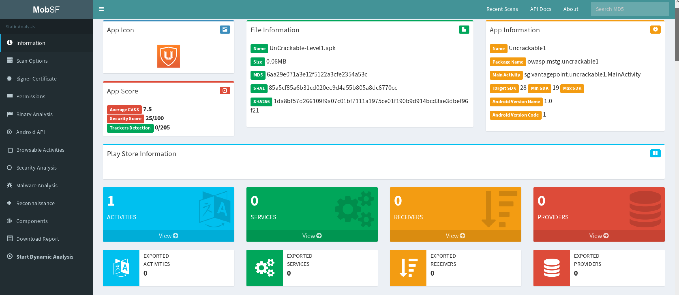
  - APKTool: Decompiles APK files to analyze manifest and code.
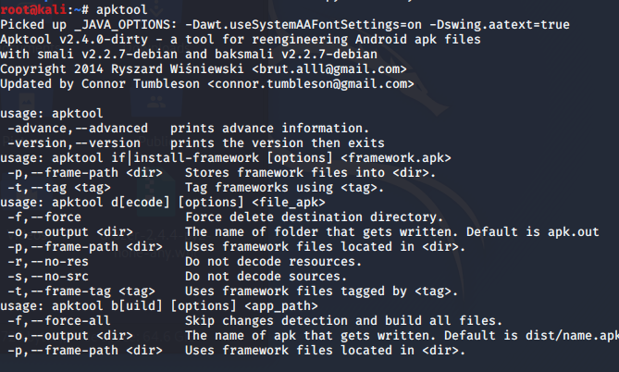
  - AndroBugs: Detects common security issues in Android applications.
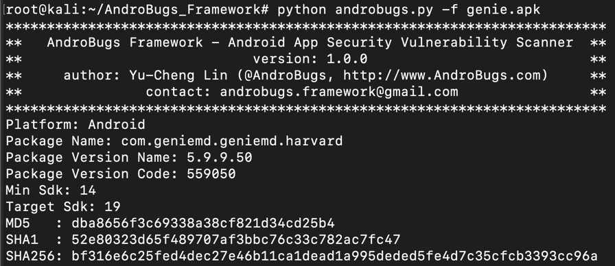

iOS:
- Tools:
  - MobSF: Also supports static analysis for iOS IPA files.

  - Class-dump: Extracts Objective-C headers for inspection.
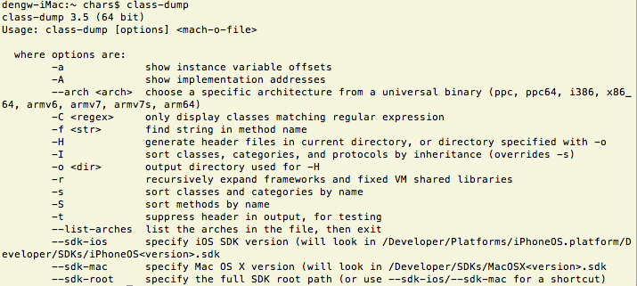
  - Hopper Disassembler: Examines disassembled binaries.
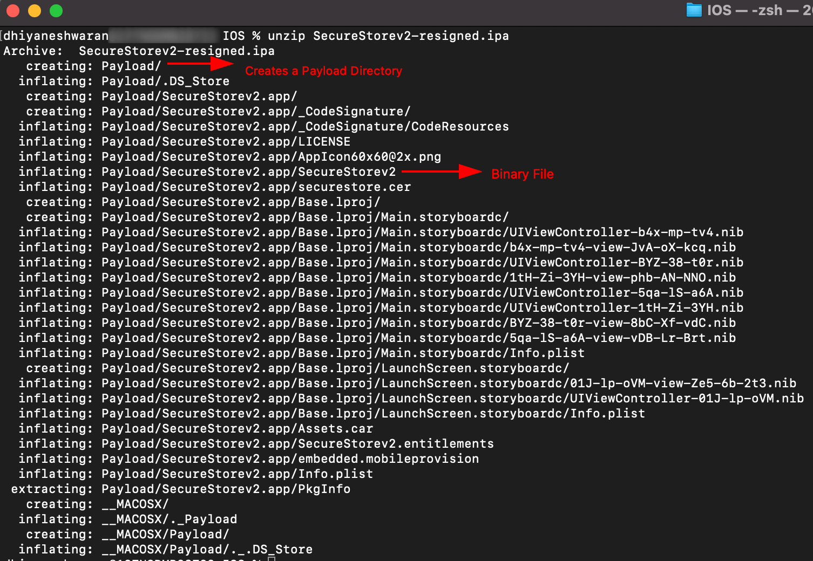

Dynamic Analysis
Android:
- Tools:
  - Burp Suite: Intercepts and analyzes app traffic.
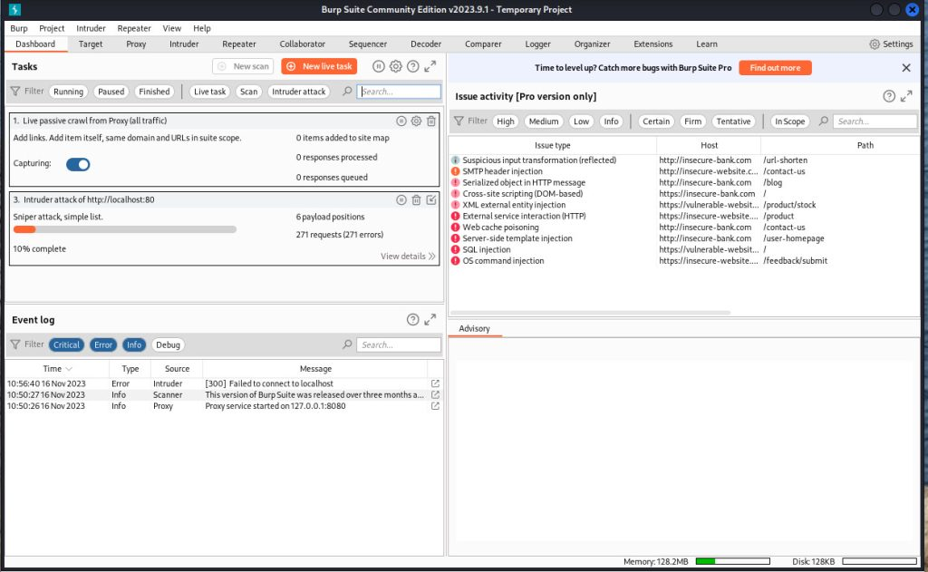
  - Frida: Performs dynamic instrumentation and function hooking.
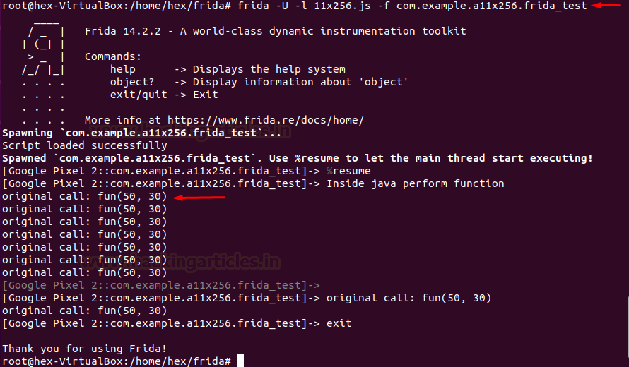
  - Drozer: Identifies security vulnerabilities in Android apps.
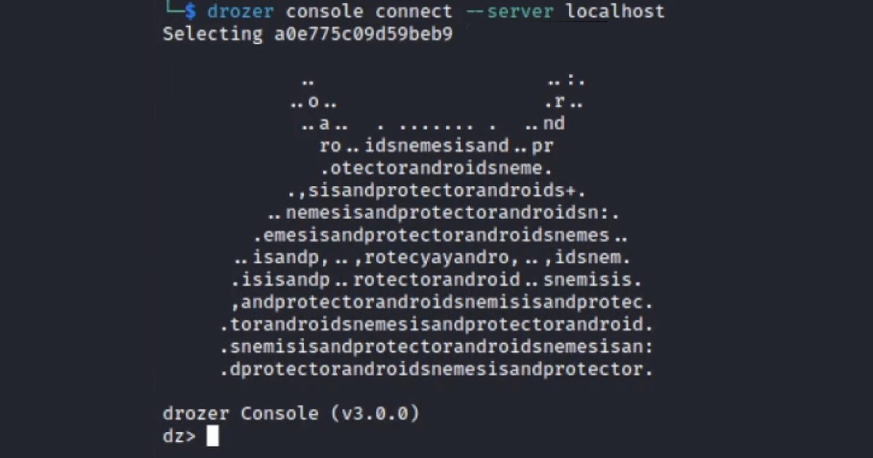
iOS:
- Tools:
  - Cycript: Analyzes runtime behavior.
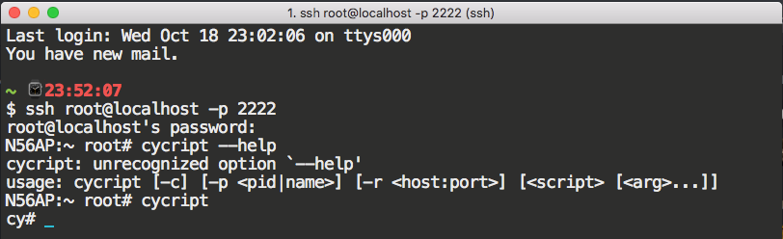
  - Frida: Also supports dynamic analysis for iOS.

  - Charles Proxy: Monitors network traffic for security loopholes.
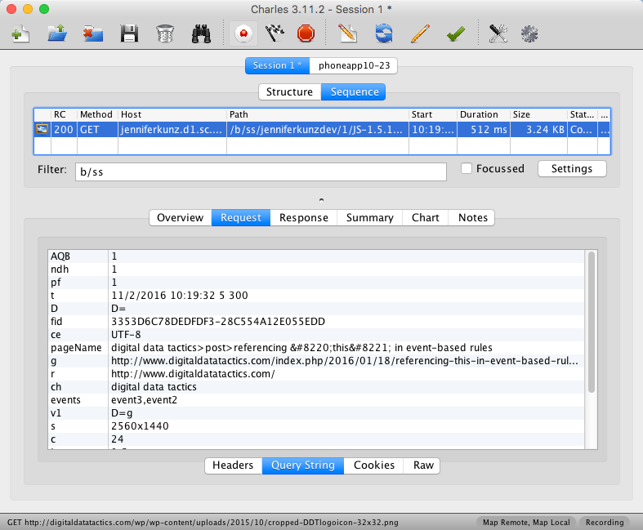

Outcomes and Knowledge Gained
Through this research, I gained:
- A comprehensive understanding of Static and Dynamic Analysis methodologies for mobile VAPT.
- Proficiency in identifying vulnerabilities using tools tailored for Android and iOS platforms.
- Insights into secure coding practices and techniques for securing mobile applications.
- Experience in simulating real-world attack scenarios to assess app security at runtime.

References
- OWASP Mobile Security Testing Guide (MSTG): https://owasp.org/www-project-mobile-security-testing-guide/
- Official tool documentation:
  - MobSF: https://github.com/MobSF/Mobile-Security-Framework-MobSF
  - Burp Suite: https://portswigger.net/burp
- "The Mobile Application Hacker's Handbook" by Dominic Chell et al.

